Scroll down to your “cisco folder” in the start menu and launch the Cisco AnyConnect client:
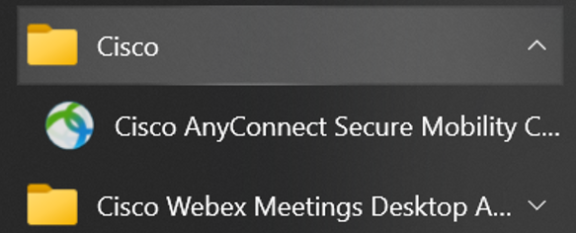

Copy and paste this URL into the text box if blank and click “connect” : houston-datafoundry-1-cmdzdmccgj.dynamic-m.com
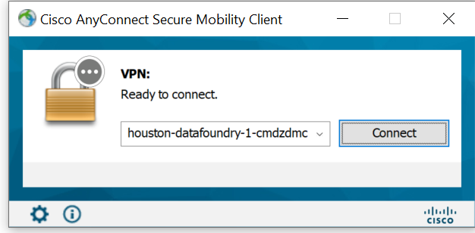
Log in with your current user ID and password. Your user ID precedes the @ symbol in your e-mail address and your password should be the same for accessing the remote server:
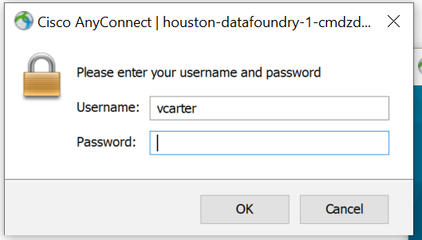
After logging in with your current password, you will receive a prompt to “approve” or “deny” in your MS Authenticator app (see instructions for installing the app on your smart phone) on your mobile device. Make sure device is unlocked:
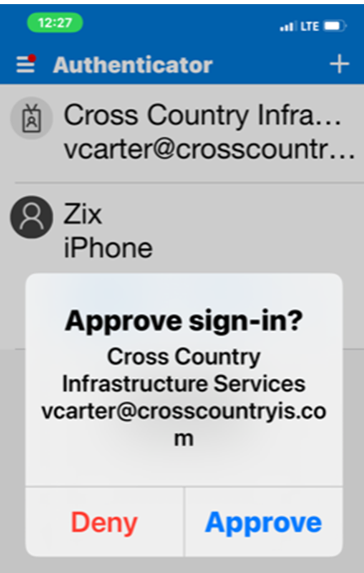
Tap “approve” and you will receive a prompt that you have successfully connected to the VPN:
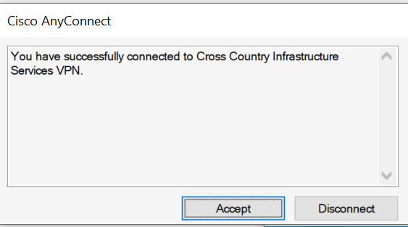

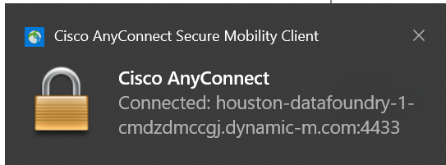

To disconnect from the VPN simply open the client from your system tray and click “disconnect”
