Download and install the Microsoft Authenticator App on your mobile phone and tap the + sign to add a new account:
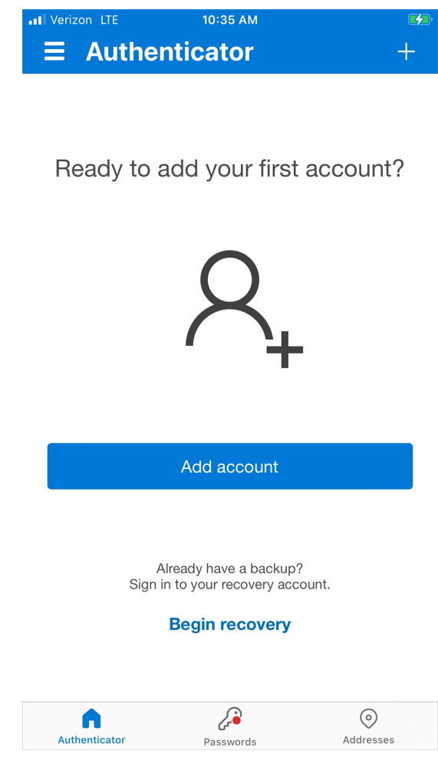

Tap “Scan a QR code;”
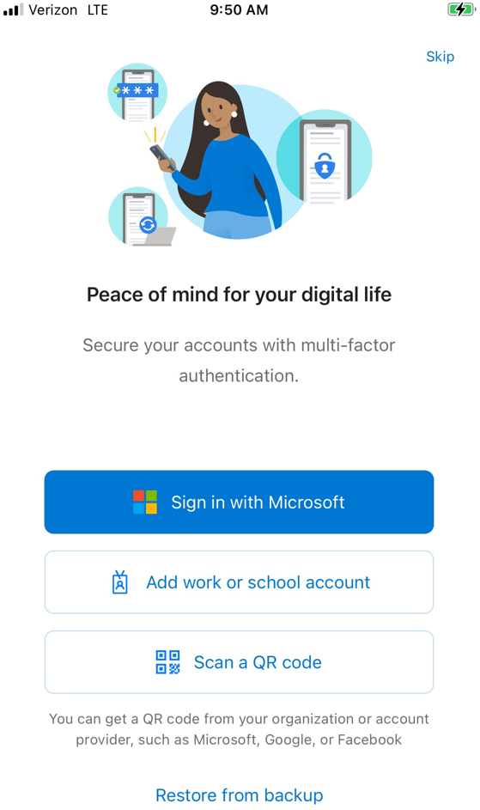

Open a web browswer on your computer and go to https://portal.office.com and log in with your CCIS e-mail address and password:
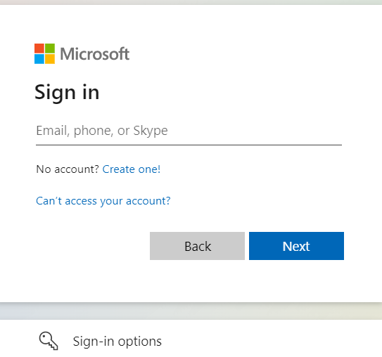
Click next:
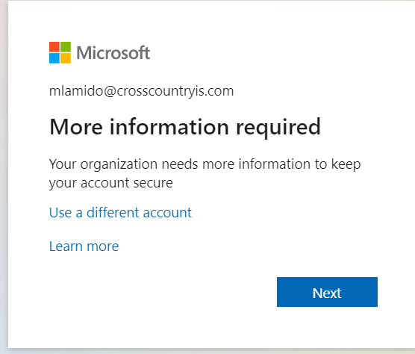
Click next:

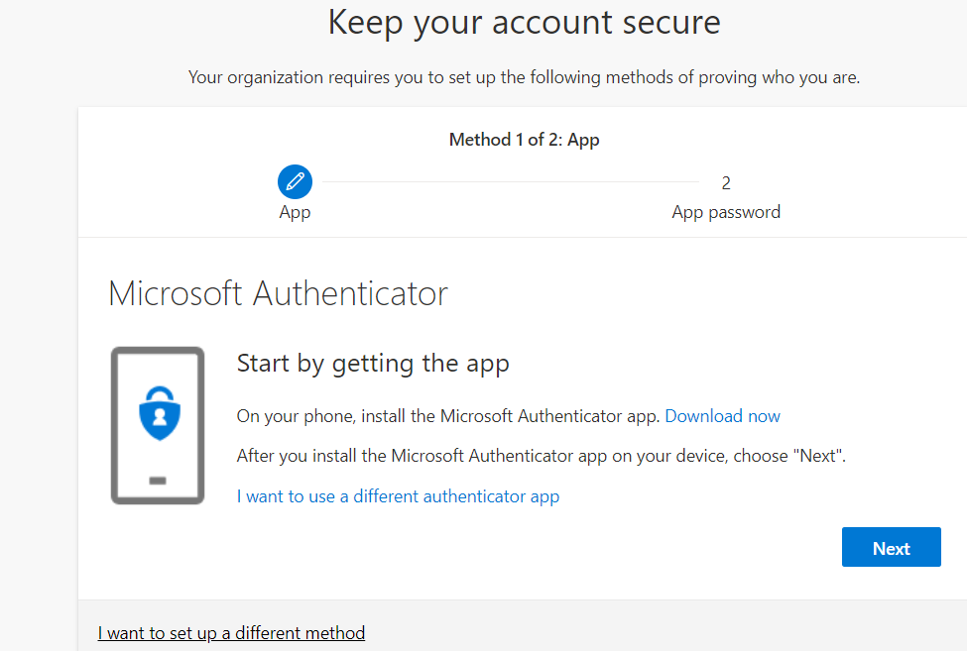

Click Next:
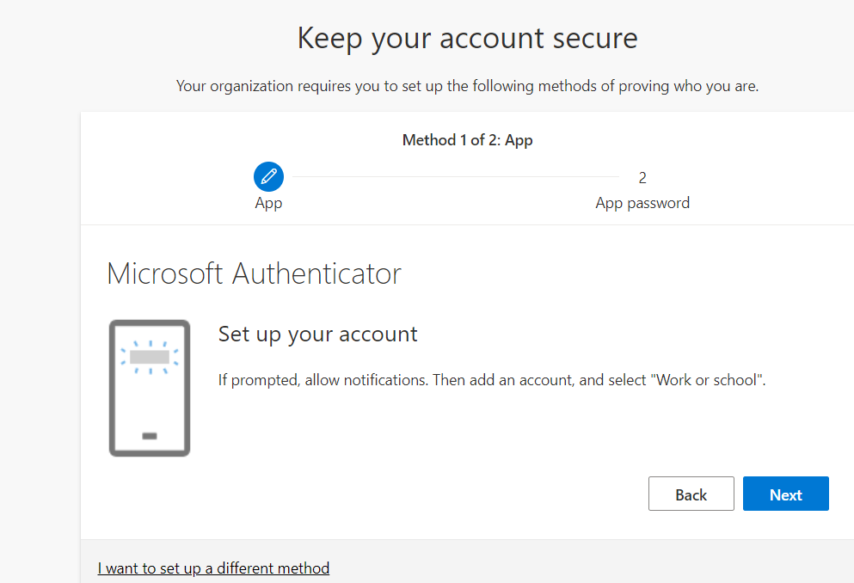

Scan the QR code with your phone:
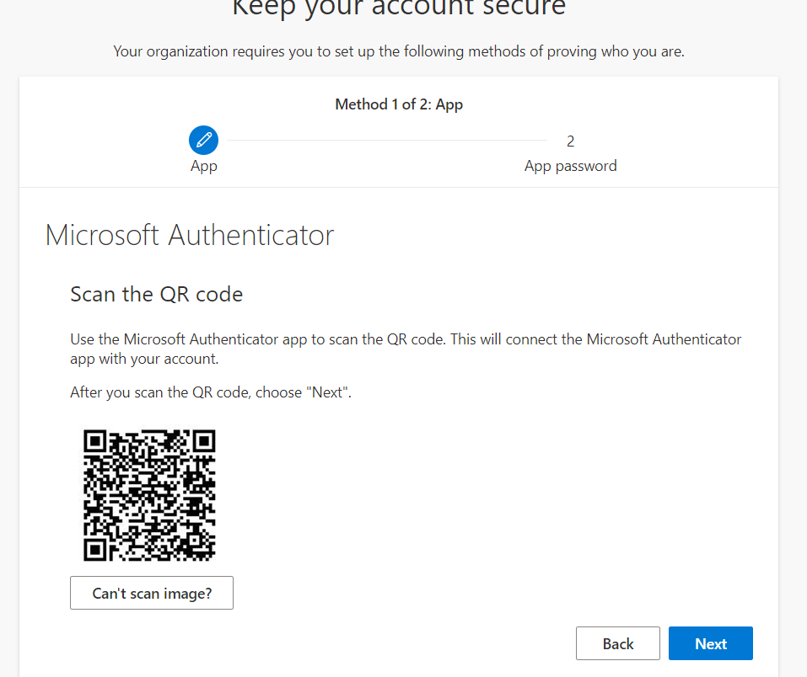
On your phone, you will see the following after scanning the QR code. Click “ok” and “allow”
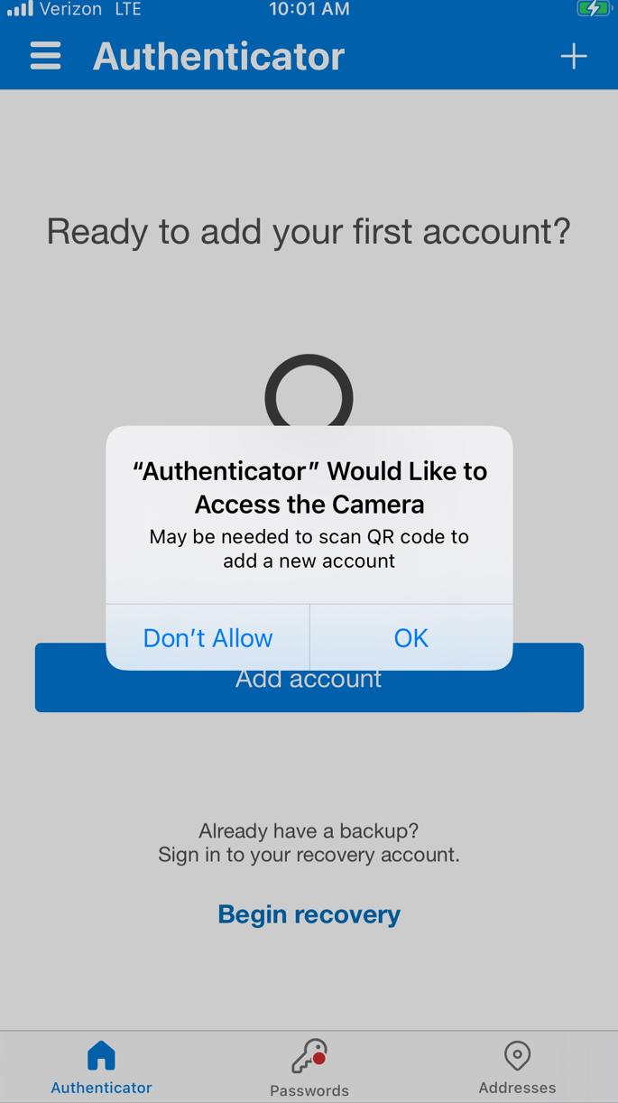
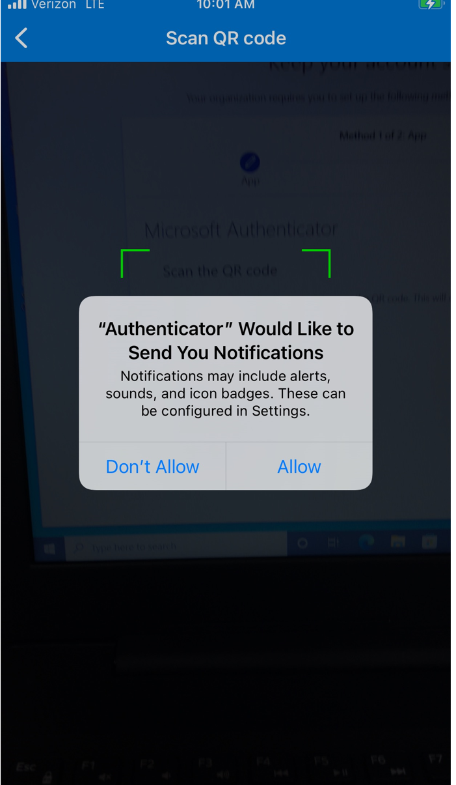
You will see the screen below if your account was successfully added:
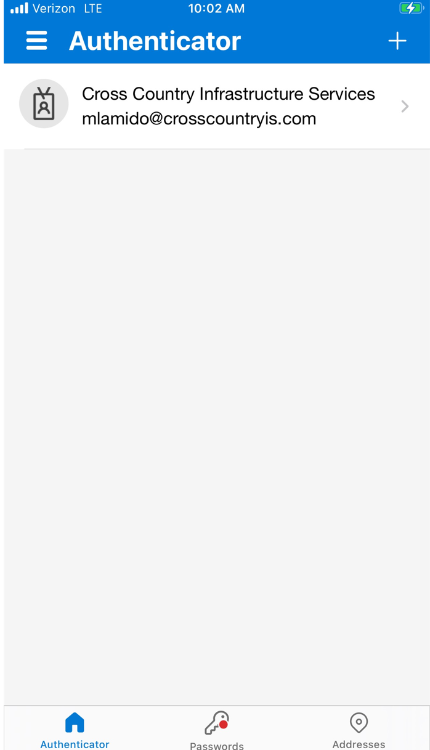
A test approval request will be sent to your MS Authenticator app for validation:

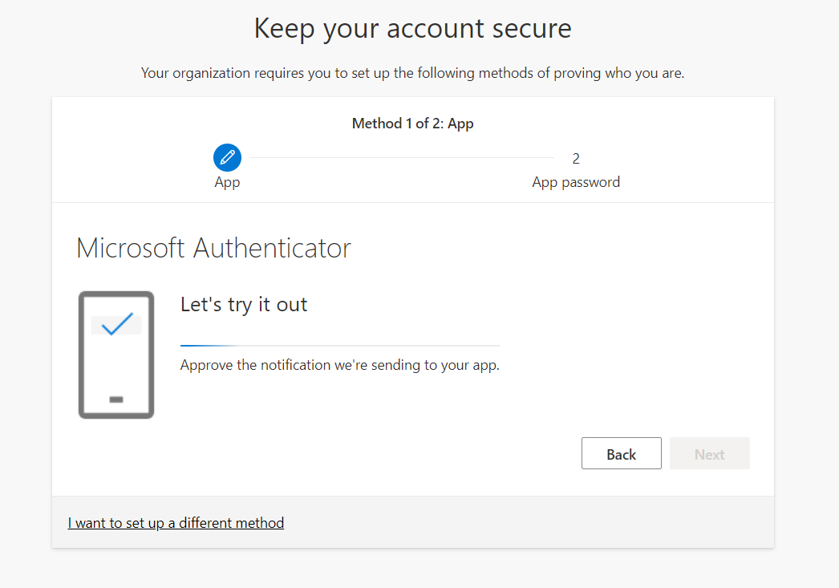
Tap “approve” on your phone. You may need to enter your phone’s unlock code a couple times:
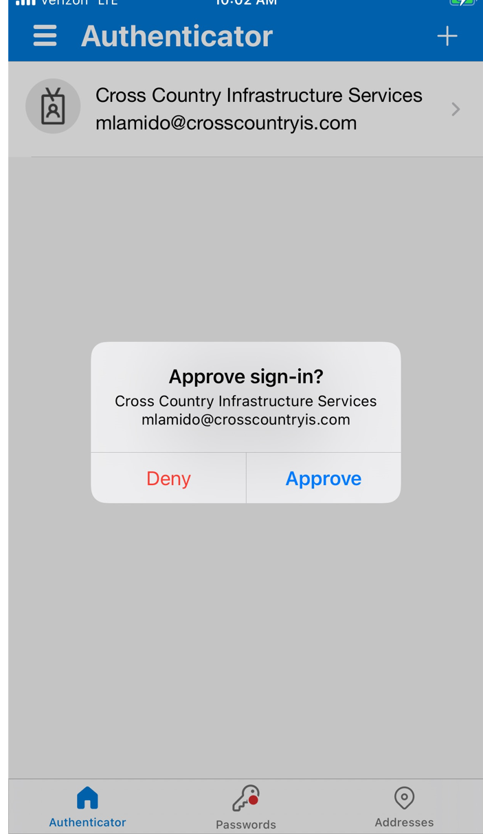
Click next and you are all set.

