Indeed Steps: Posting a job.
Select Post Job.
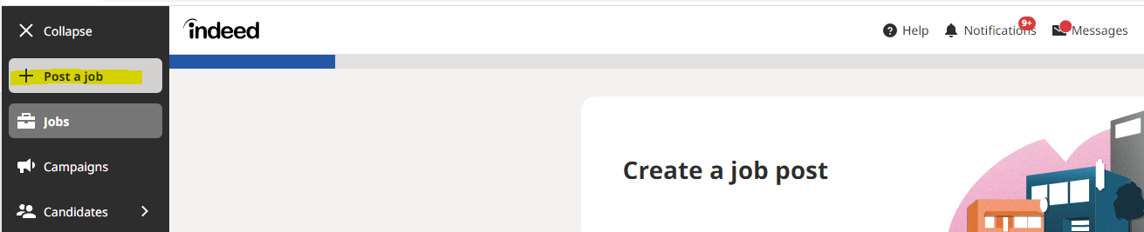
Start with a new post, when you start with a new post it will show up for job seekers.
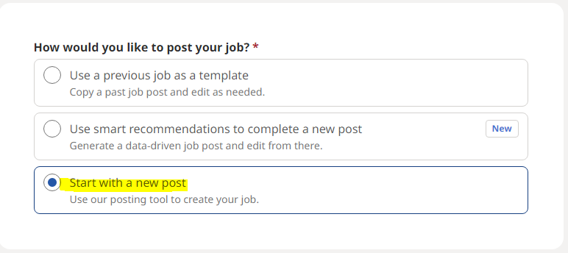
Input Job Title, Describe the job location, Provide street address for the location. Please ensure that you are not displaying the street address on the job post. Example is below:

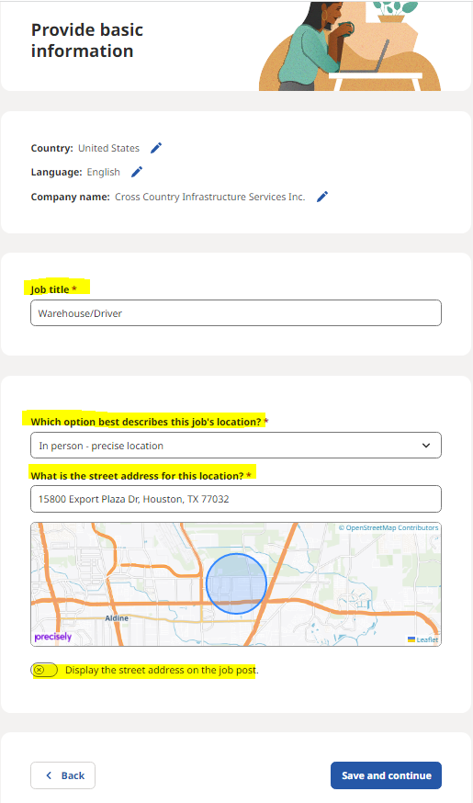

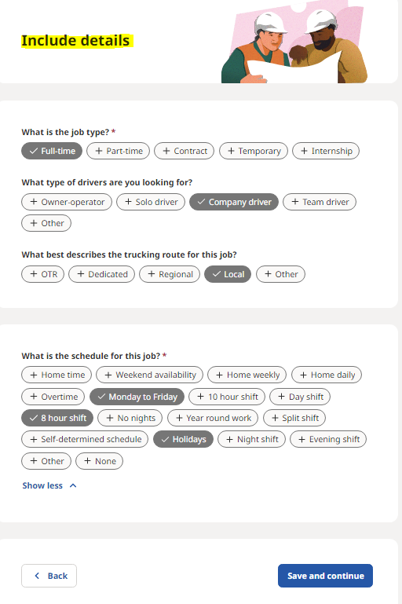
Select Save and Continue on bottome right.

Confirm the pay, and ensure that you are selecting “starting amount”.
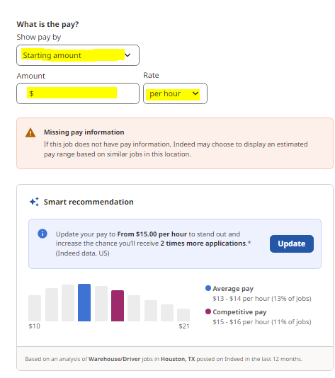
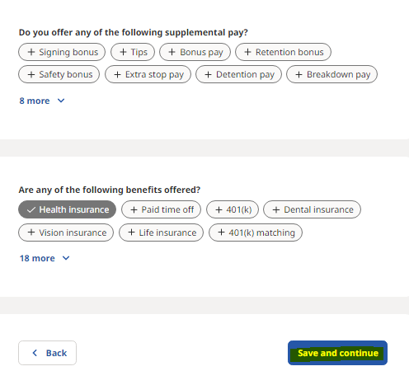
Select Save and Continue

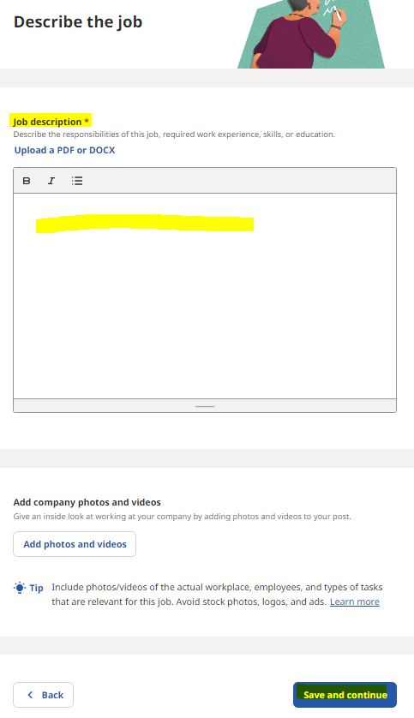
Ensure that applicants are submitting a resume, input your e-mail address, if you would like to receive an individual e-mail upon applications feel free to do so. Not recommended to let candidates contact you directly.
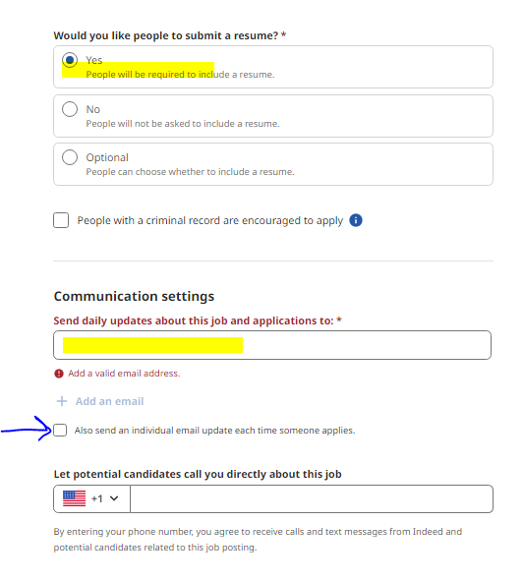

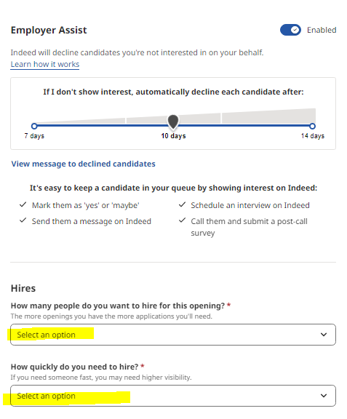

Not recommended to allow candidates to invite themselves to introductory calls.
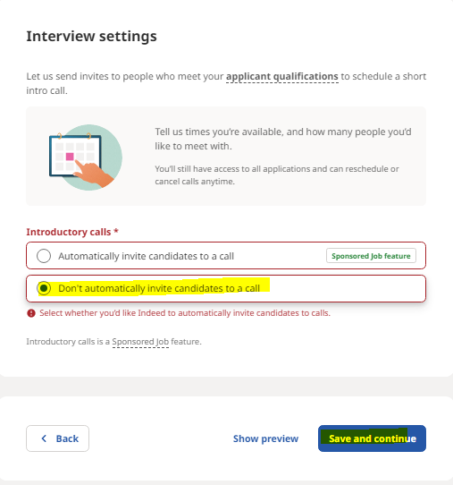
Review the job post and confirm

Review the qualifications prior to posting.
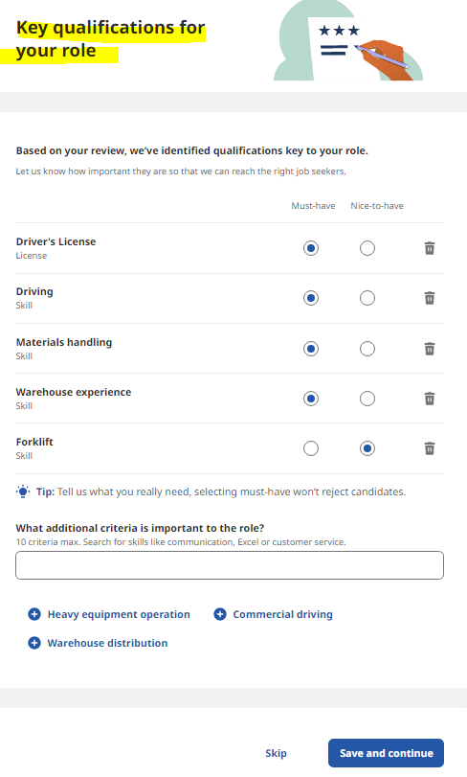
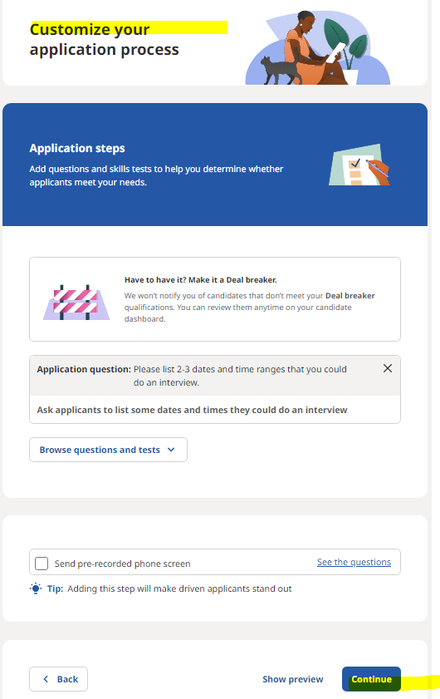
Select Continue and your job is posted!

You will have the ability to manage the job status by dropping down and pausing, opening or closing.

