ANDROID SETUP
GO TO EMAIL INBOX
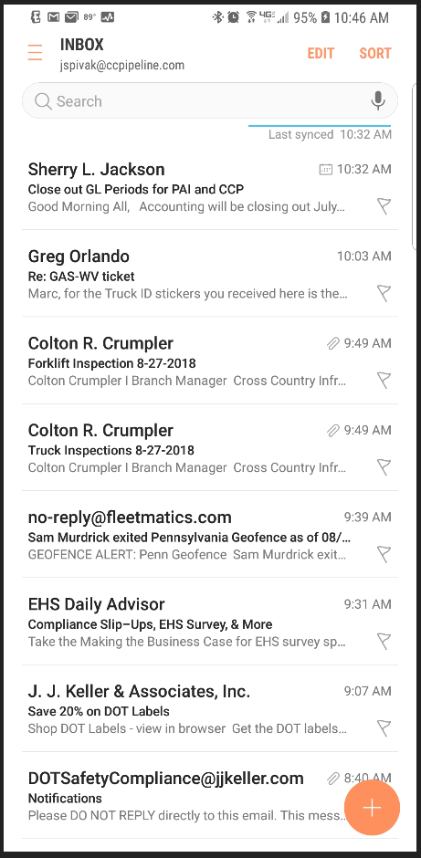
Press Here
OPEN SETTINGS
Press Here
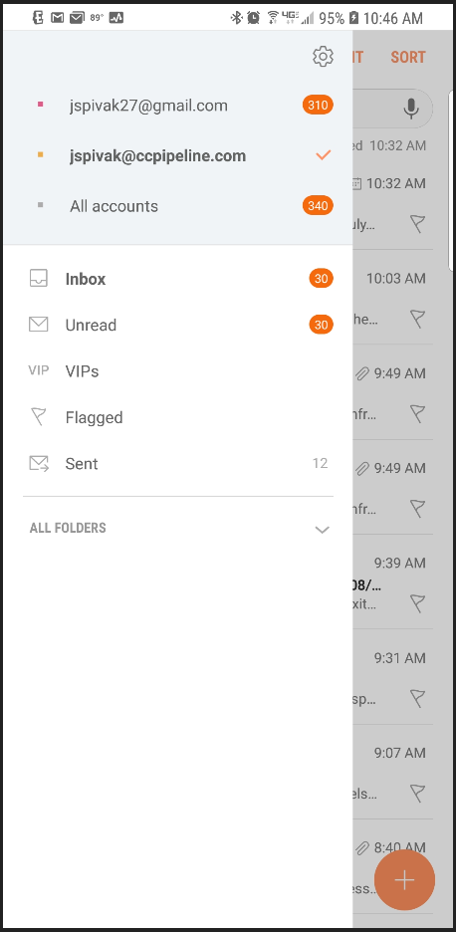
ADD AN EMAIL ACCOUNT
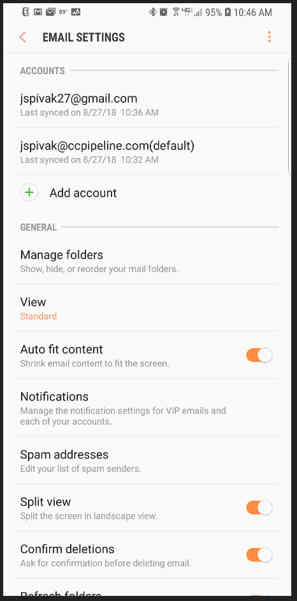
Press Here
ADD A CORPORATE ACCOUNT
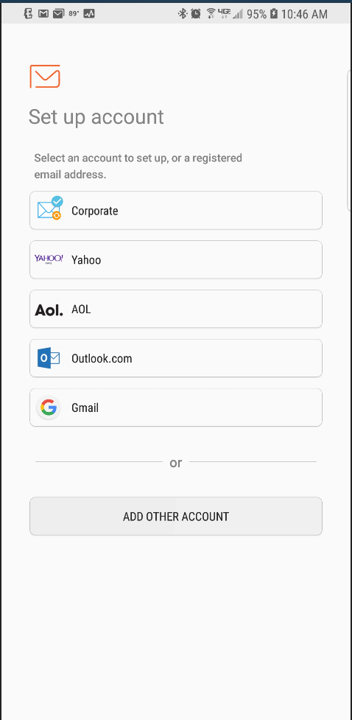
Press Here
ENTER USER NAME AN PASSWORD
