IPHONE IOS SETUP
- GO TO SETTINGS
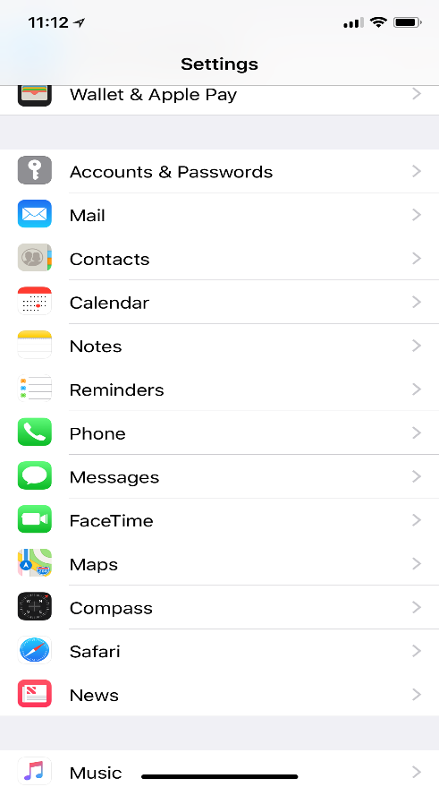
Click Here
- ADD ACCOUNT
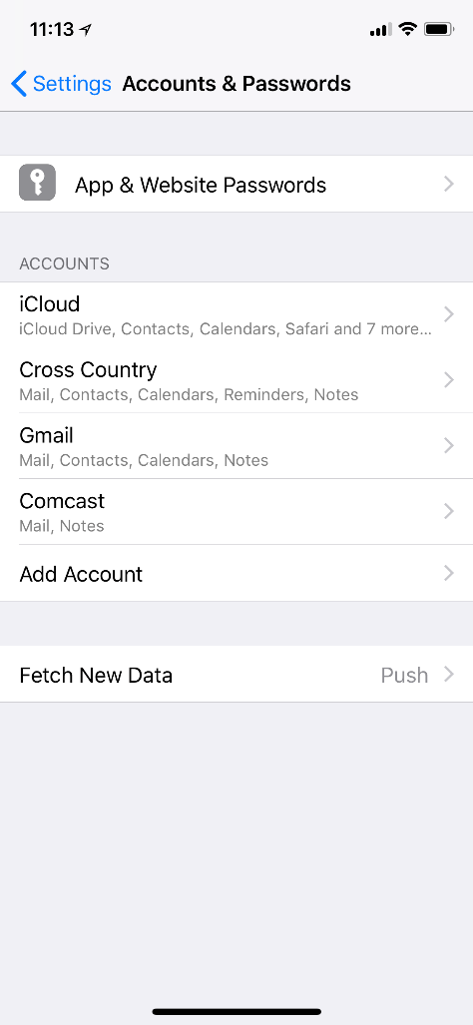
Click Here
- CLICK “Exchange”
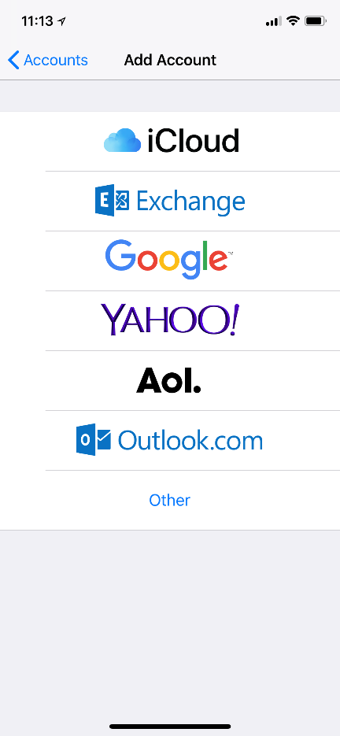
Click Here
- ADD A CORPORATE ACCOUNT
Enter CCIS Email Address using first initial then last name @ CCPIPELINE.COM.
i.e.: John Doe would be JDOE@CCPIPELINE.COM . Contact ITSUPPORT@CCPIPELINE.COM if you have any questions
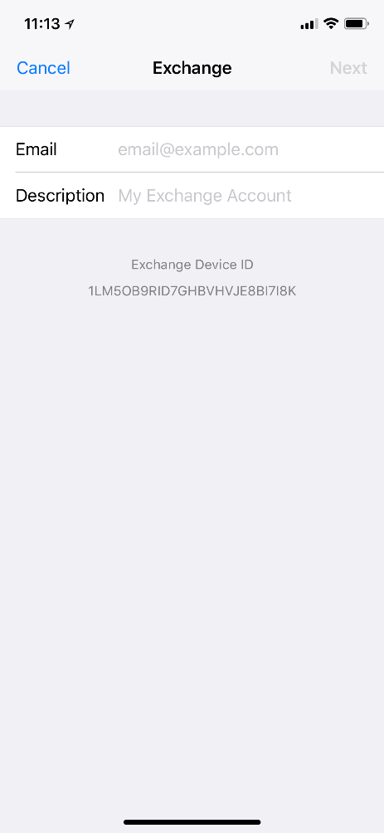
Add “EXCHANGE” description here.
- SIGN IN TO EMAIL
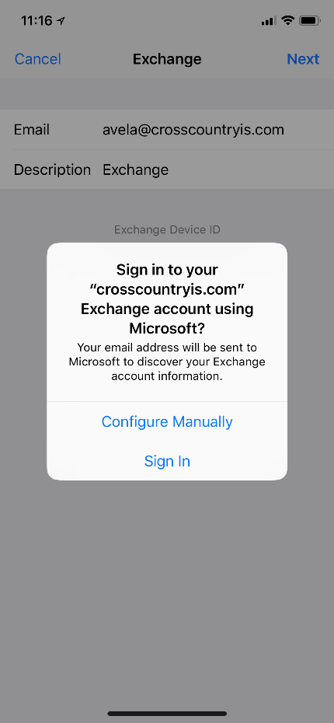
Click Here
- ENTER PASSWORD
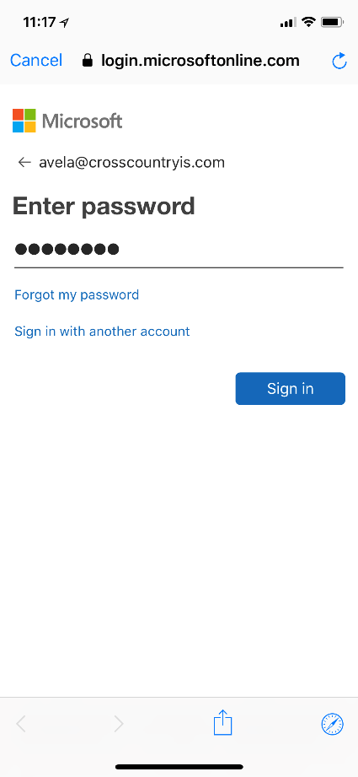
Enter Password provided by your Manager or contact ITSUPPORT@CCPIPELINE.COM if you have any questions

- CLICK “ACCEPT”
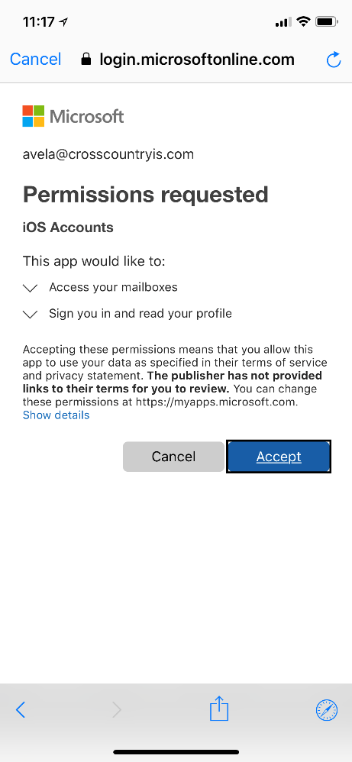
Click Here
- SET PERMISSIONS
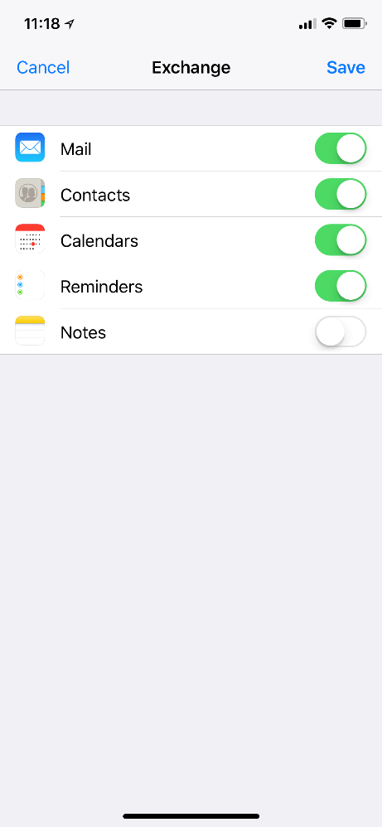
You may need to reboot to initiate settings. Contact ITSUPPORT@CCPIPELINE.COM if you have any questions

