Cross Country- Existing User- Access Reports

Log in: Open Internet Browser and type in the following to the address bar
www.powerbi.com

click “Sign In” once the webpage appears
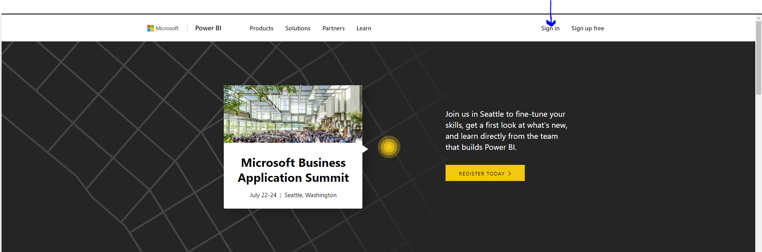

Enter Username/Password (this is your Windows log in information), and click “Sign In”
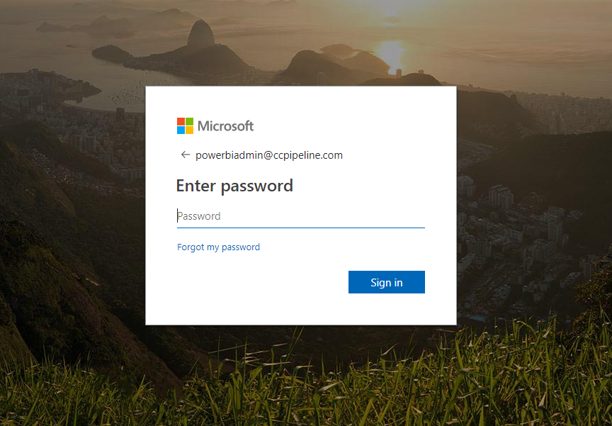

To access Cross Country Power BI reports, click on Apps in the left-hand column
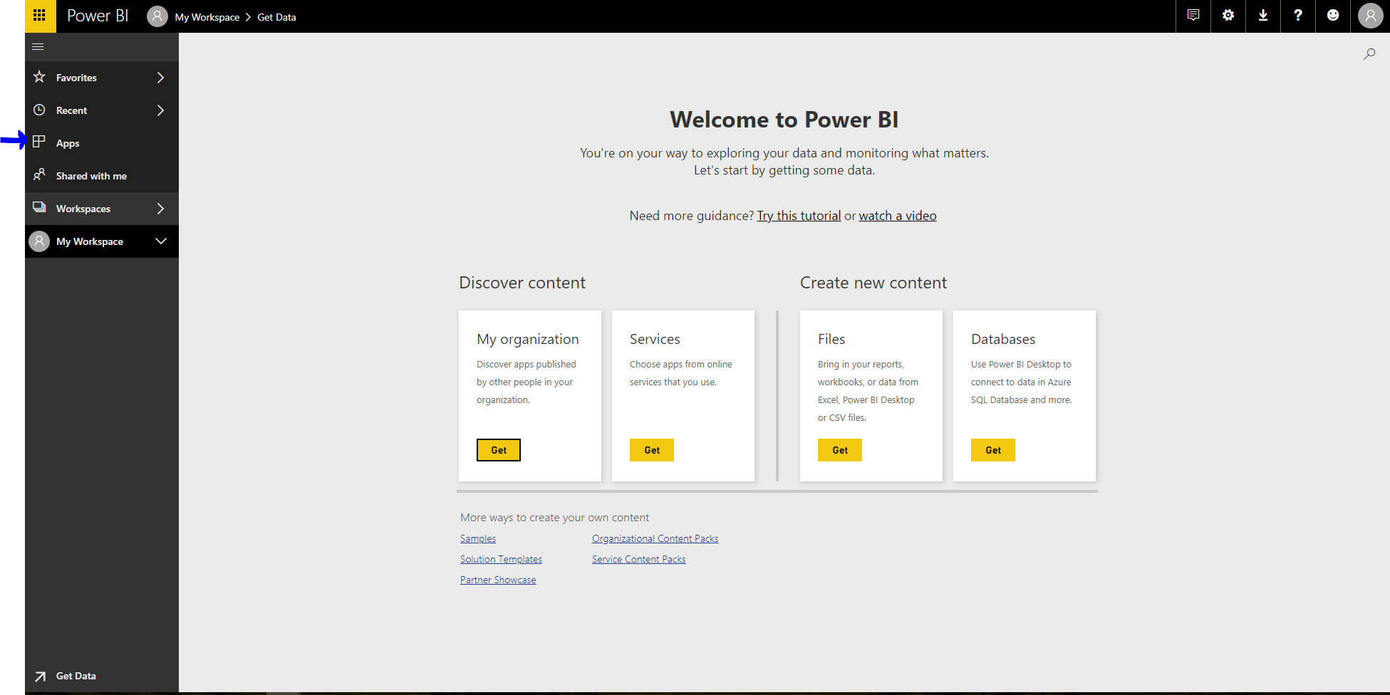

Cross Country will now appear in your Apps. To begin to view reports, click on Cross Country.
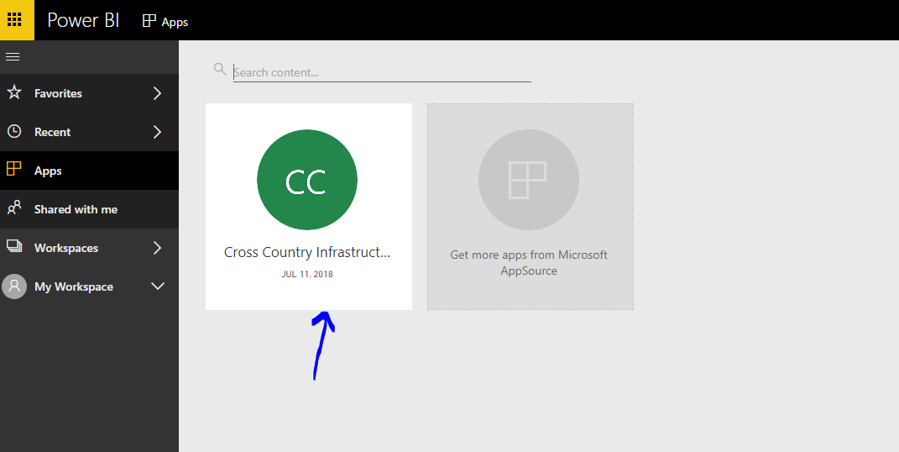

All available reports will now appear. Click on which report you would like to see.
You are now able to view/access reports. To view more indexing reports including:
- Branch Managers
- Customer Data
- Equipment Utilization
- Fleet Management
- Supply Chain

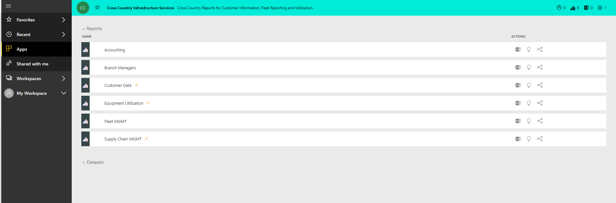

To go back to the list of reports, click the “View Content List” button in the top corner. This will take you back to your list of reports
