Cross Country- New User- How to log & Download Power BI App

Log in: Open Internet Browser and type in the following to the address bar
www.powerbi.com

click “Sign In” once the webpage appears
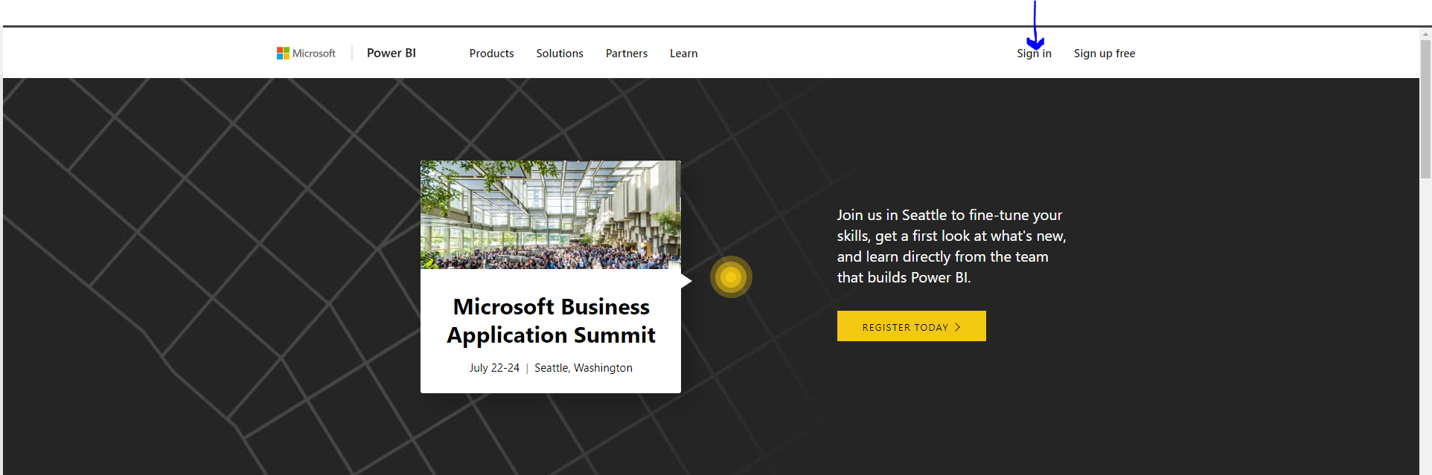

Enter Username/Password (this is your Office 365 log in information), and click “Sign In”
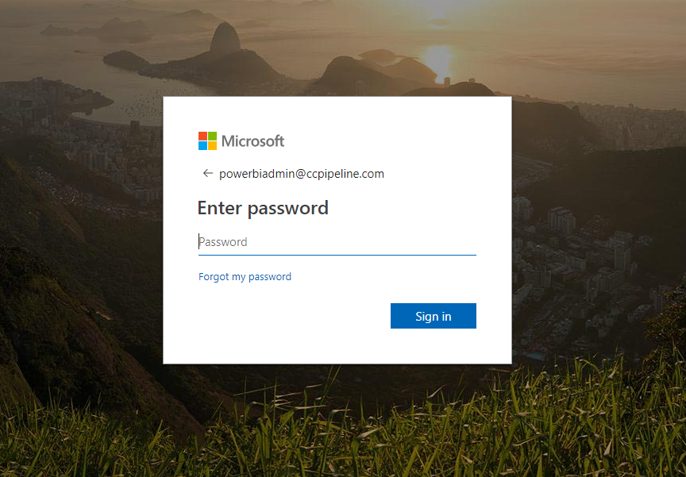

To access Cross Country Power BI reports, click on Apps in the left-hand column
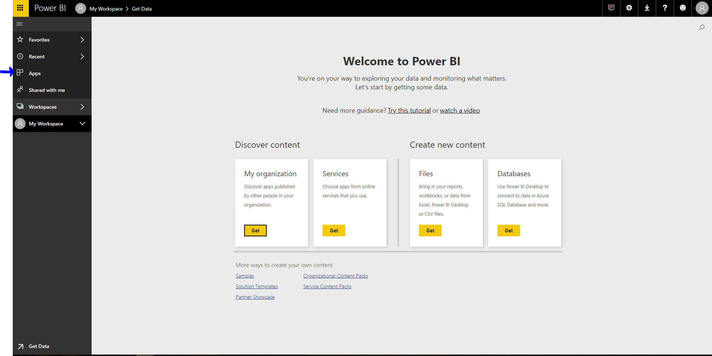

Click the yellow button to “Get apps”
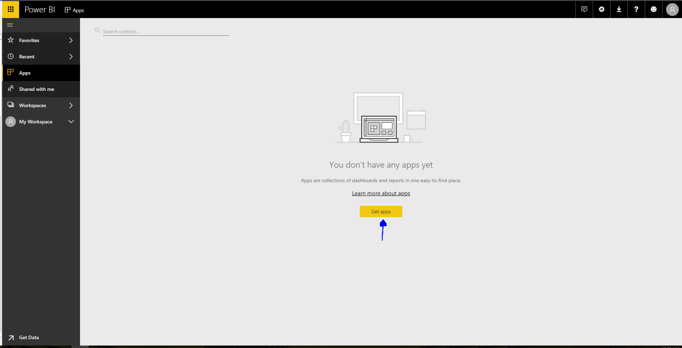

Once AppSource appears, Cross Country Infrastructure Services Power BI should appear- Click the button “Get it Now”
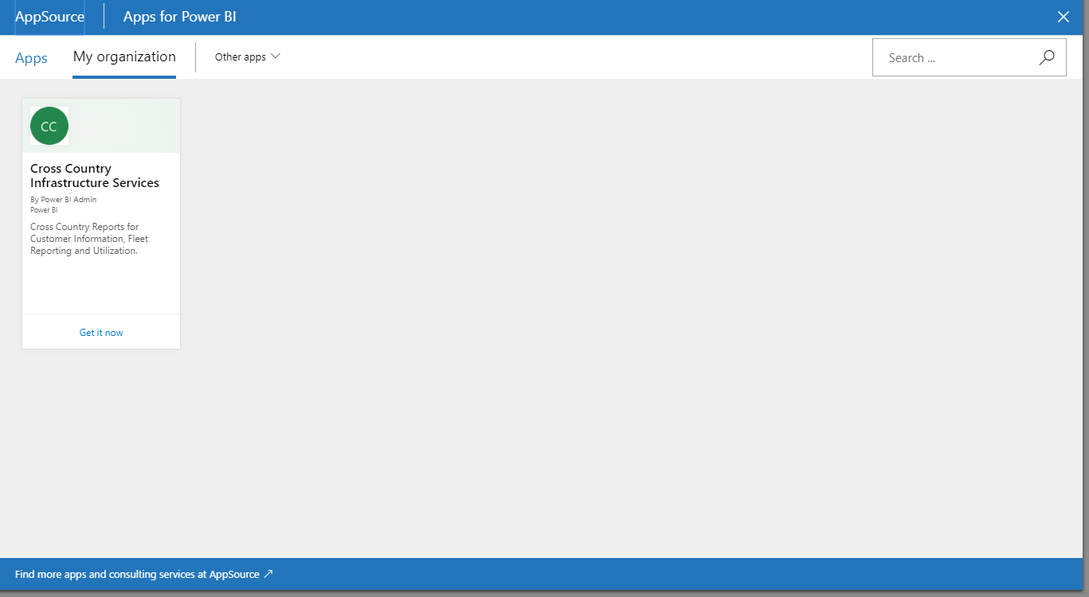

Once the app loads, Cross Country will now appear in your Apps. To begin to view reports, click on Cross Country.
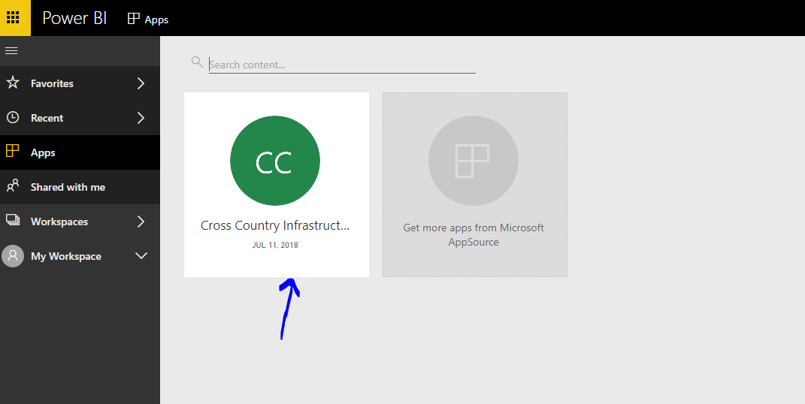

All available reports will now appear. Click on which report you would like to see.
You are now able to view/access reports. To view more indexing reports including:
- Branch Managers
- Customer Data
- Equipment Utilization
- Fleet Management
- Supply Chain

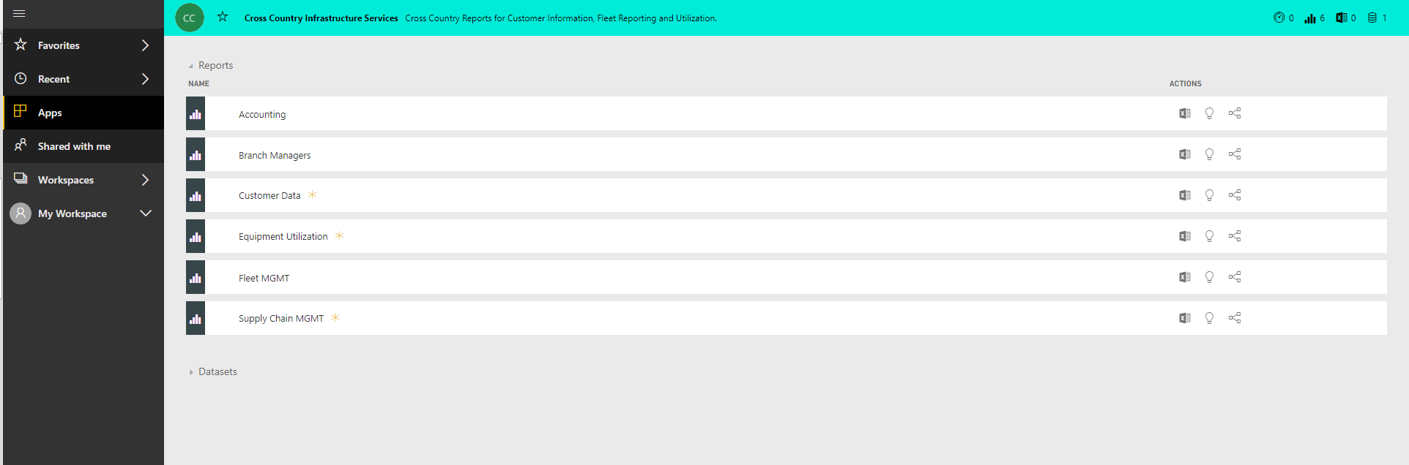

To go back to the list of reports, click the 4 lines button in the top corner. This will take you back to your
