QA/QC Incident Report

REPORTED BY: |  |  | DATE OF REPORT:
TITLE / ROLE: |  |  | INCIDENT NO.:
RENTED TO: |  |  | CUSTOMER CONTACT
RENTED FROM: |  |  | CCIS CONTACT

TYPE OF INCIDENT: ☐QAQC ☐PROPERTY DAMAGE ☐ SPILL ☐ NON-DOT VEHICLE ☐ DOT VEHICLE ☐ OTHER: ____________________________________

INCIDENT INFORMATION
INCIDENT TYPE: |  |  |  |  |  | DATE OF INCIDENT
LOCATION OF INCIDENT |  |  |  |  |  | CITY:___________________ |  | STATE: ZIPCODE:
MANUFACTURE __________________________________ |  |  |  |  |  |  | MFG. CONTACT ___ _________________________________
EST. ASSET VALUE __________________________________ |  |  |  |  |  |  | EST. REPAIR COST _________________________________
OTHER ASSOCIATED COSTS___________________________ |  |  |  |  |  |  | PROPERTY OWNER _________________________________
SPECIFIC AREA OF LOCATION:
NAME / ROLE / CONTACT OF PARTIES INVOLVED:
WITNESSES NAME AND CONTACT INFO.:
INCIDENT DESCRIPTION INCLUDING ANY EVENTS LEADING TO THE INCIDENT:
INCIDENT DESCRIPTION INCLUDING ANY EVENTS IMMEDIATELY FOLLOWING THE INCIDENT:
RESULTING ACTION EXECUTED, PLANNED, OR RECOMMENDED:

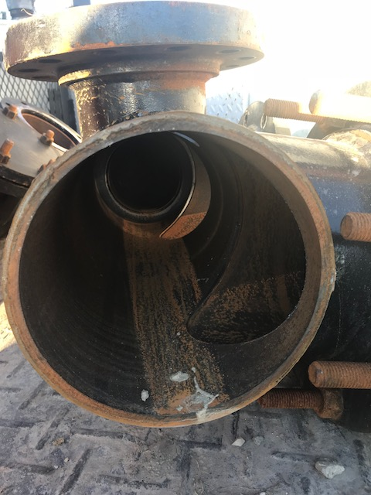
ATTACH PHOTO 1 DESCRIPTION:

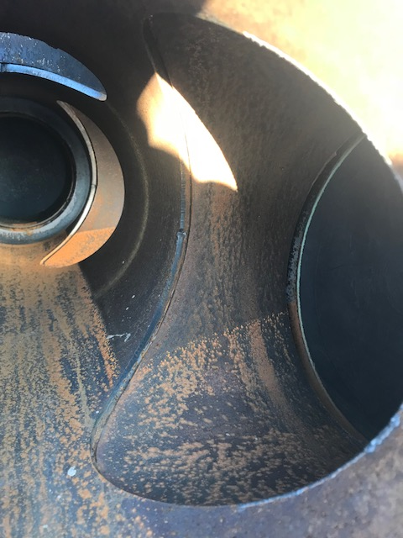
ATTACH PHOTO 2 DESCRIPTION:

ATTACH PHOTO 3 DESCRIPTION:

