Launch VMWare Horizon Client application. Click the down arrow at the top right corner next to the three dashes then click “software updates.”
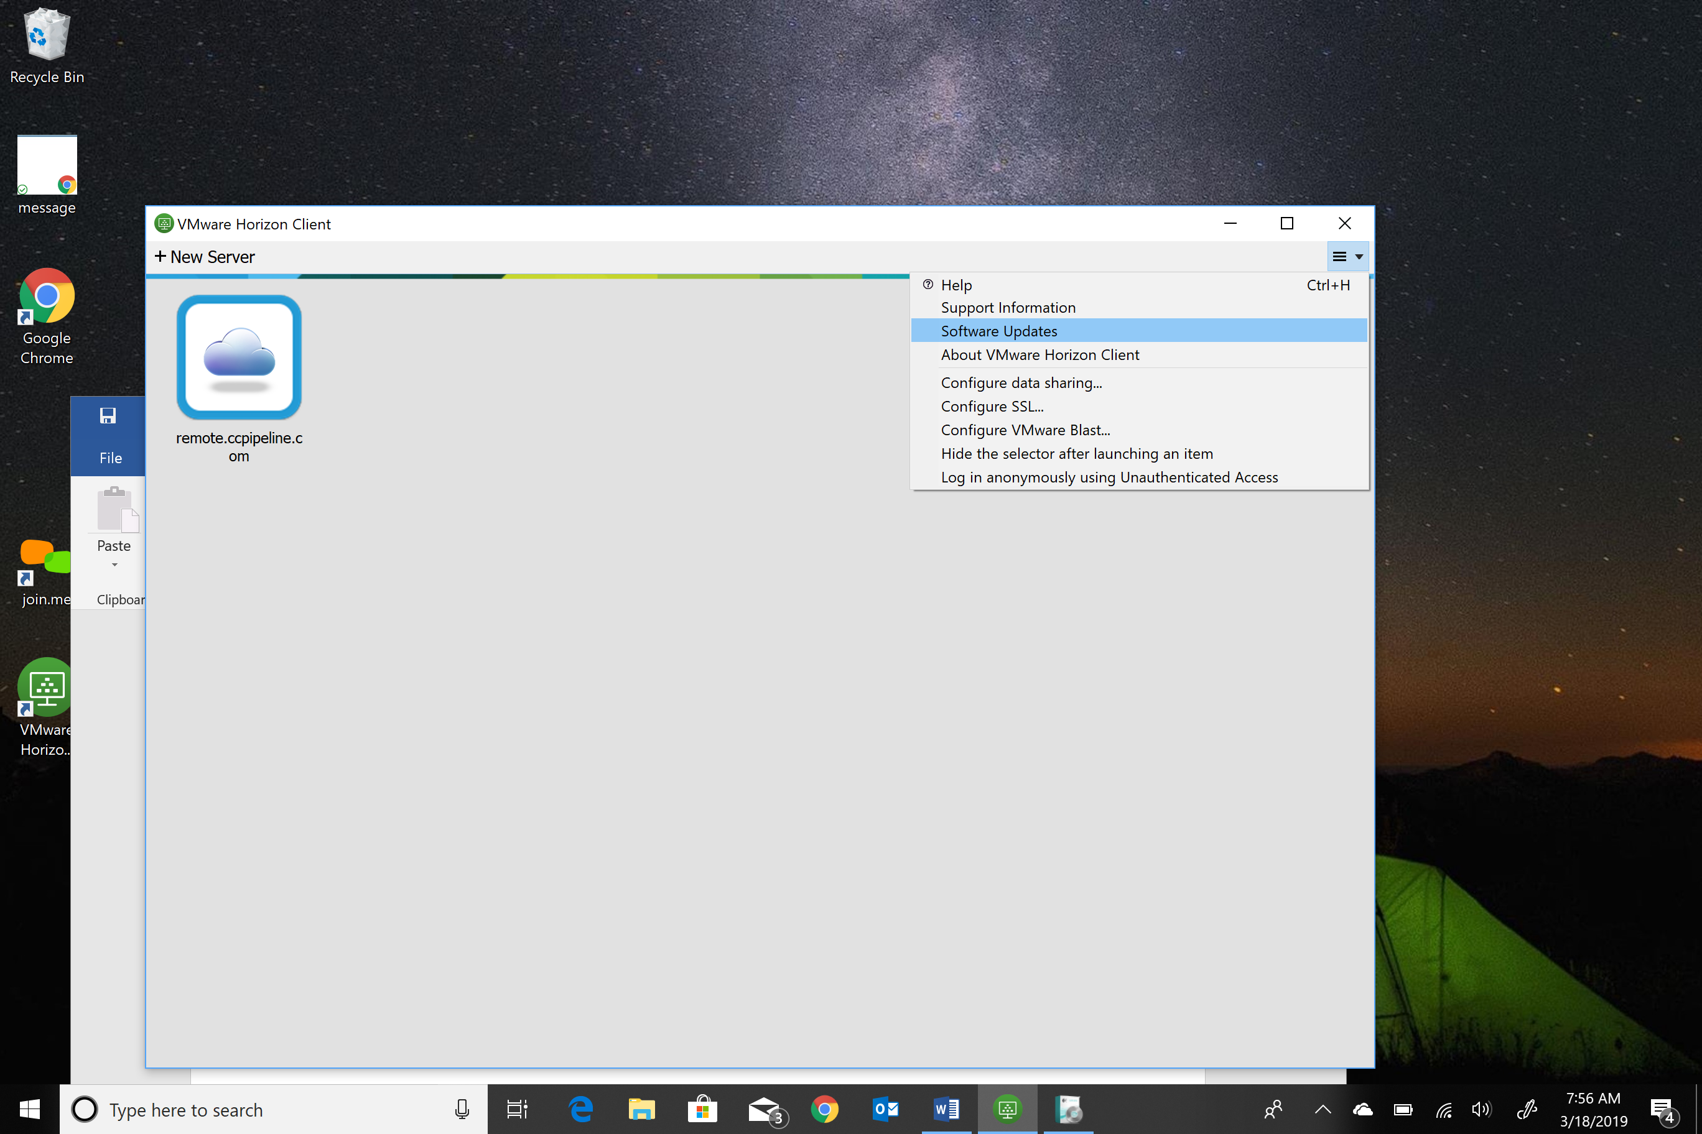
Click “download and install.” The current version is 5.0.
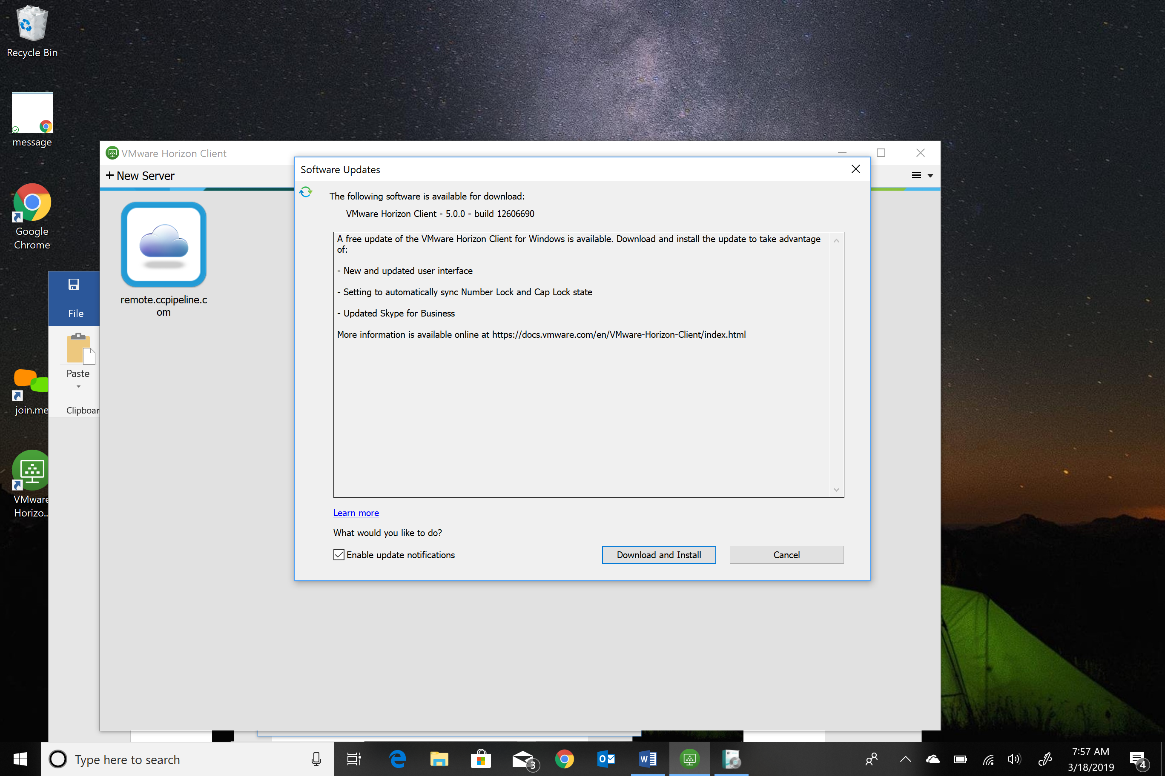
The download status bar should appear:
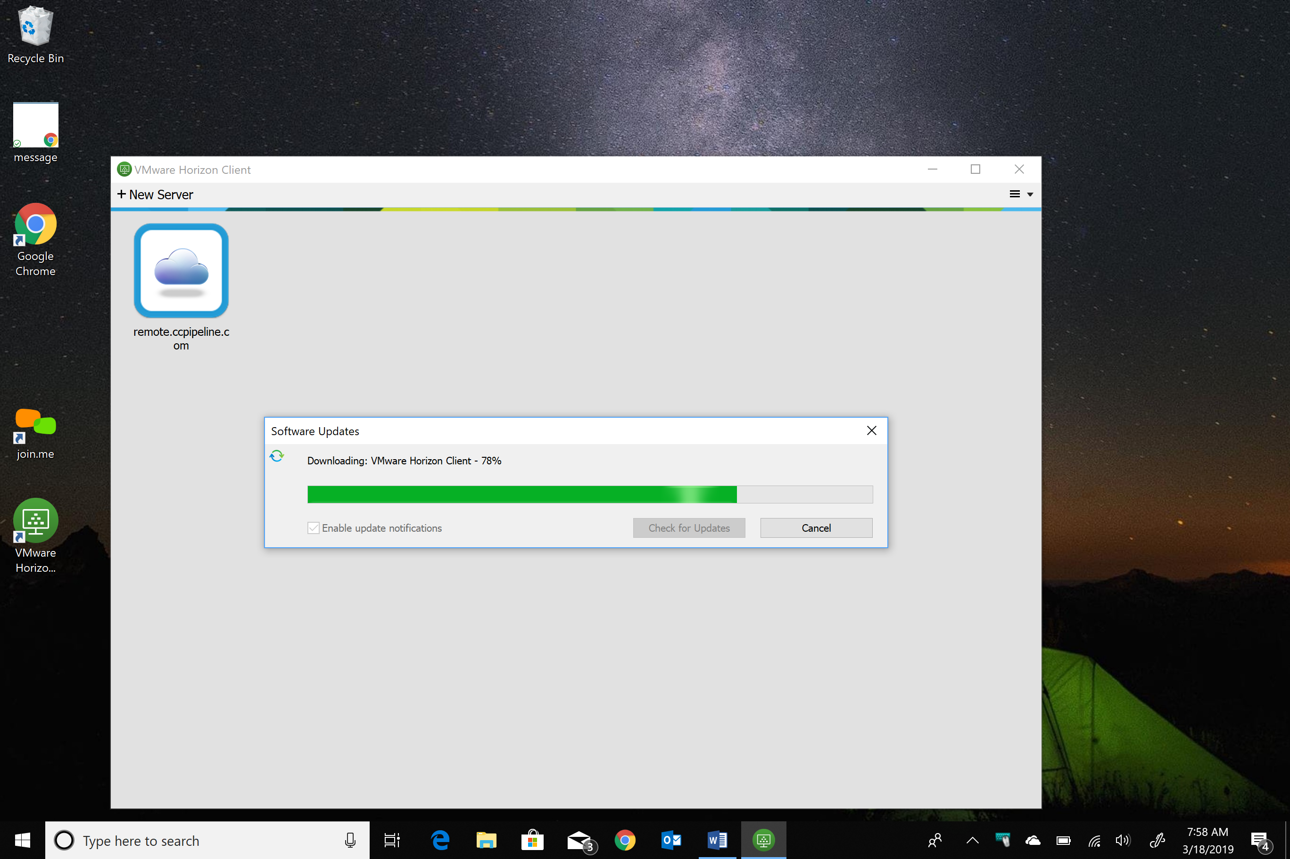
Click ok for the software to install:
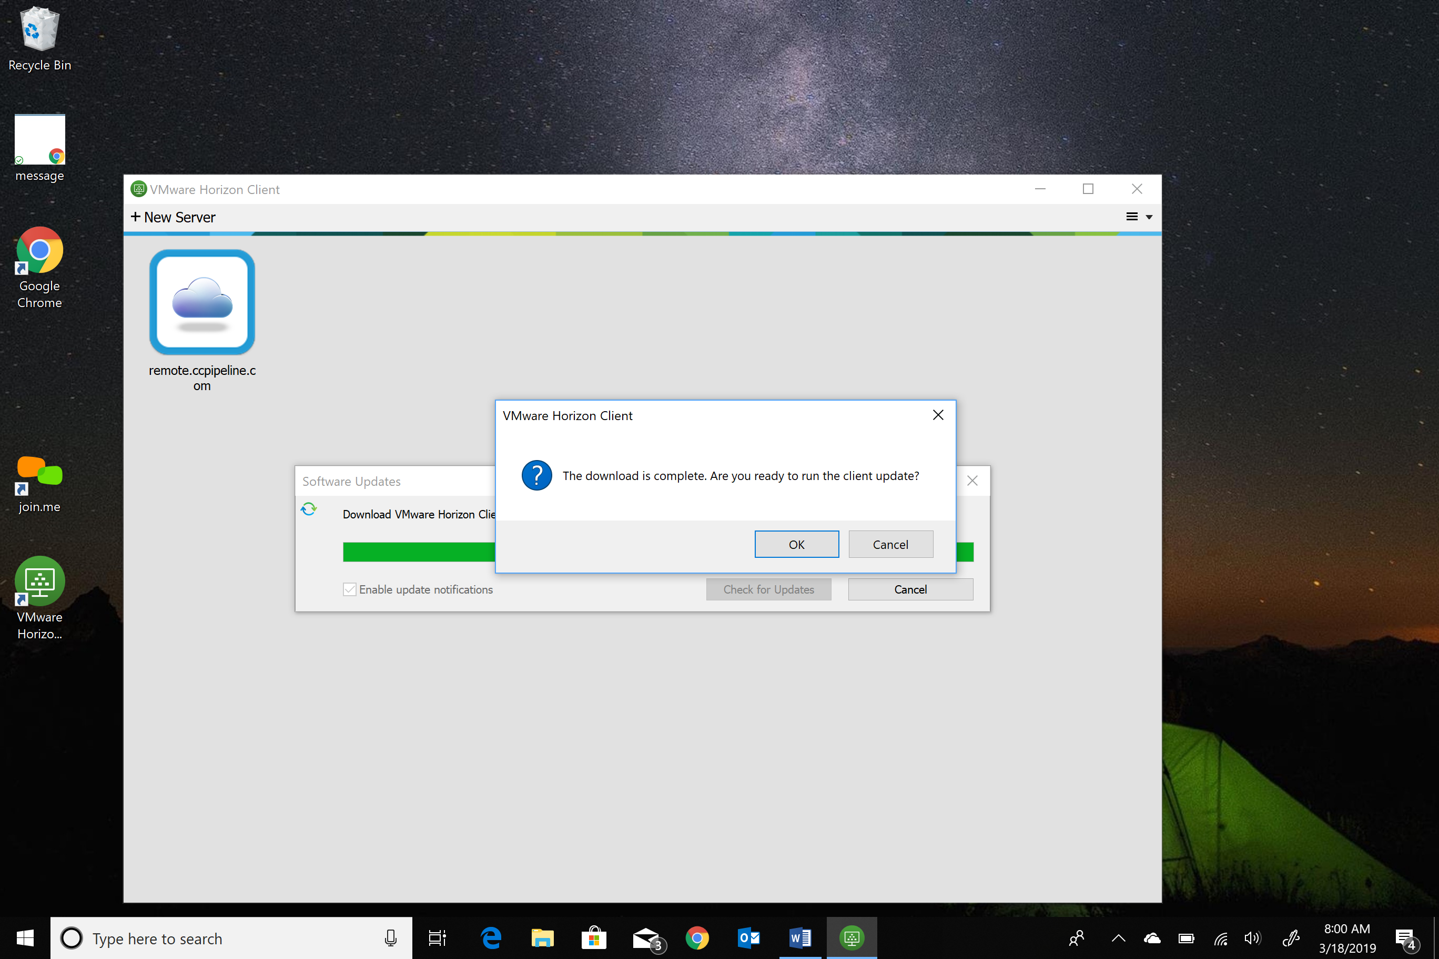
Click “agree & upgrade.” A message box will appear to confirm you want the software to make changes to your computer. Click yes.
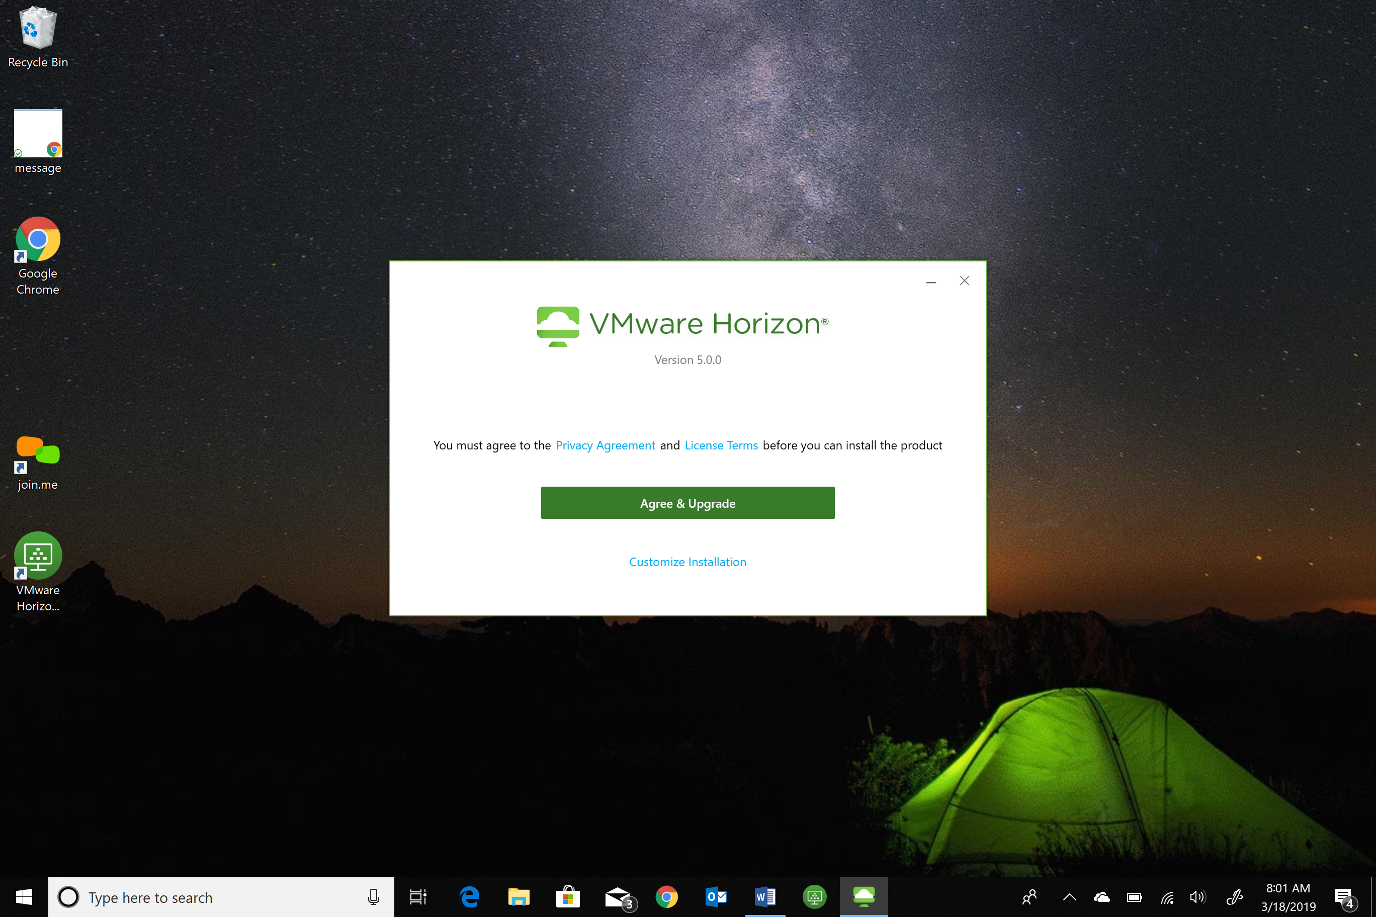
This window will appear as VMWare Horizon client is applying changes and upgrading to the current version.
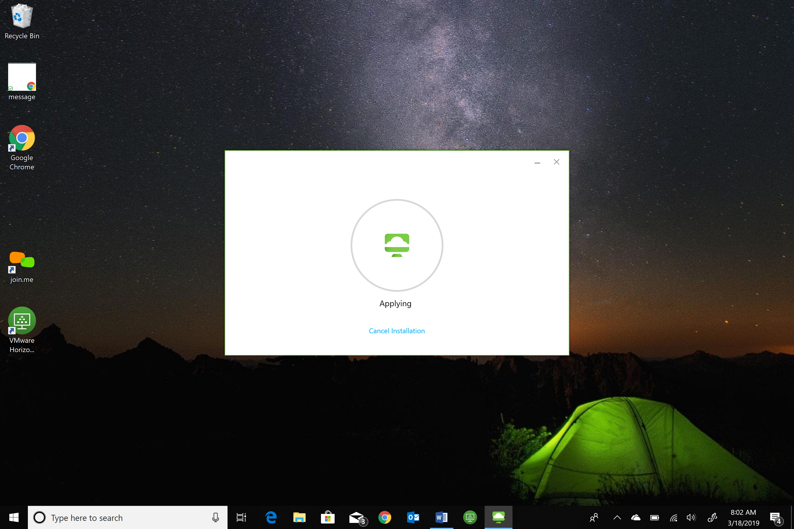

Click “finish and restart now.”
