Vehicle Incident Report Form
(A blank copy of this form must be maintained in all company vehicles)
Driver Information
Driver Name |  | Address |  | Work Phone
Date of Birth |  | City State Zip |  | Home Phone
Date of Hire | Driver License Number / State

Vehicle Information
Vehicle Number | Year |  | Make |  | Model | Vehicle Identification Number (VIN)
License Plate Number |  |  |  | Mileage | Area of Damage
Accident during business use?  Yes No |  | Is the Vehicle Drivable?  Yes No |  |  | Location of Vehicle/ Tow Company

Accident Information

Date of Accident | Time | Location of Accident (Street, Highway or intersection)
City |  | County | State

Other Vehicle Information (Use additional sheet if necessary)
Year | Make | Model |  |  | License Plate Number | Driver’s License Number
Owner Name |  |  |  | Phone | Address City State Zip
Driver Name (if other than owner) |  |  |  | Phone | Address City State Zip
Insurance Carrier |  |  | Policy Number |  | Agent Name / Phone Number
Area of Damage to Vehicle |  |  |  |  | Vehicle Location

Conditions and Accident Description (use additional sheet if necessary)
Weather Conditions (Rainy, Clear, Foggy, Snow, etc.) |  | Road Conditions (Paved, Dry, Wet, Icy, etc.) |  | Air Bag Deployed?  Yes No
Traffic Controls (Signs, Signals, Lights) | Posted Speed Limit |  | How fast were you traveling? | Seat Belts Worn  Yes No
Description of the Accident:
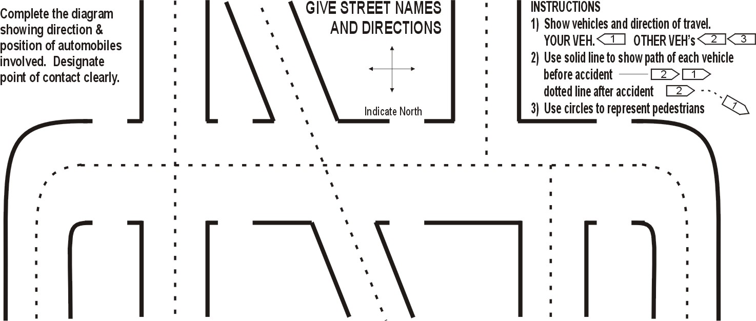

Witnesses
Name | Address City State Zip | Phone
Name | Address City State Zip | Phone

Passengers circle one
Name | Address City  State Zip | Phone | Our veh.  Other veh.
Name | Address City  State Zip | Phone | Our veh.  Other veh.

Injuries
Name |  | Address City State Zip
Phone | Extent of Injuries
Name |  | Address City State Zip
Phone | Extent of Injuries

Police Information
Were Police Called?  Yes No | Police Department Contact / Precinct Number / Phone Number
Officer Name / Badge Number | Report Number
Citation / Ticket Issued / Reason | Who was cited (Our Driver, Other Party)?

Report Reviewer Title Date

Instructions:
- Check to make sure no one is injured. If so, request medical assistance immediately.
- If your vehicle is drivable, you to move it off of the traveled portion of the roadway as soon as practical. If not drivable, turn on hazard lights, and if available, set up flares or reflector triangles to warn traffic. Stay in your vehicle.
- Call the police immediately, even if it appears minor. If police will not respond, due to an “accident alert” situation or do not come, fill out an accident report at the city courthouse/ police station in the city in which the accident occurred.
- Ask the police officer, if completed, where and when you can get a copy of their report.
- Do not argue with the others involved, admit fault or discuss the accident with anyone except the police.
- Give the other driver your vehicle insurance policy number (should be kept with vehicle registration information.)
- Gather as much information about the accident as possible.
- If a camera is available, photograph the scene from four directions. Also photograph the damage to each vehicle.
- Complete the Vehicle Incident Form and submit to the safety@crosscountryis.com for review.

